LAB 6 -Report
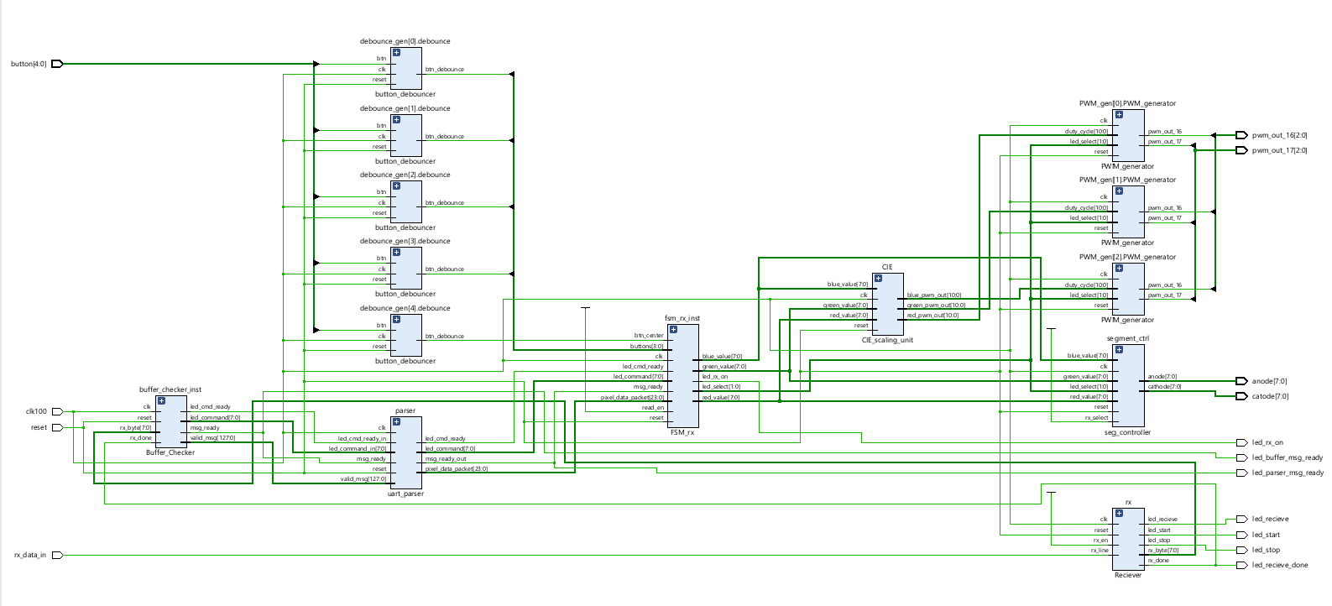
Lint Schematics
System State Machine - Diagram
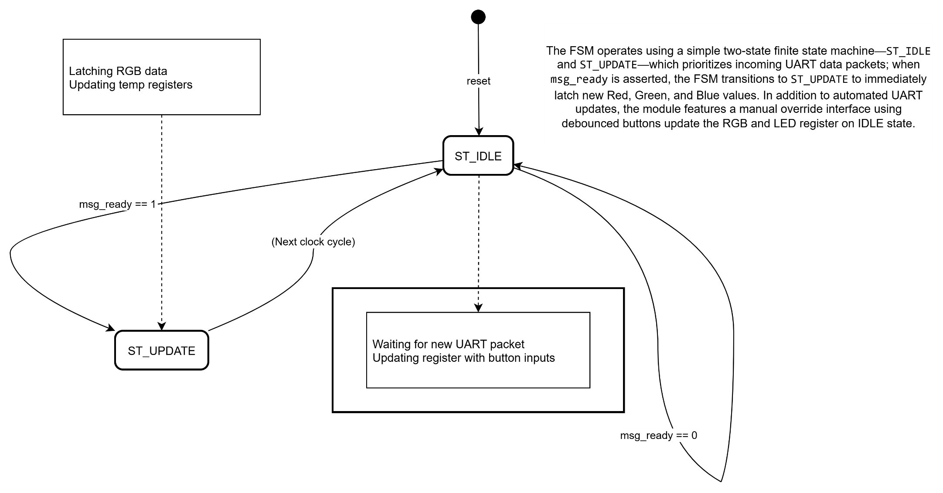

System Block - Diagram

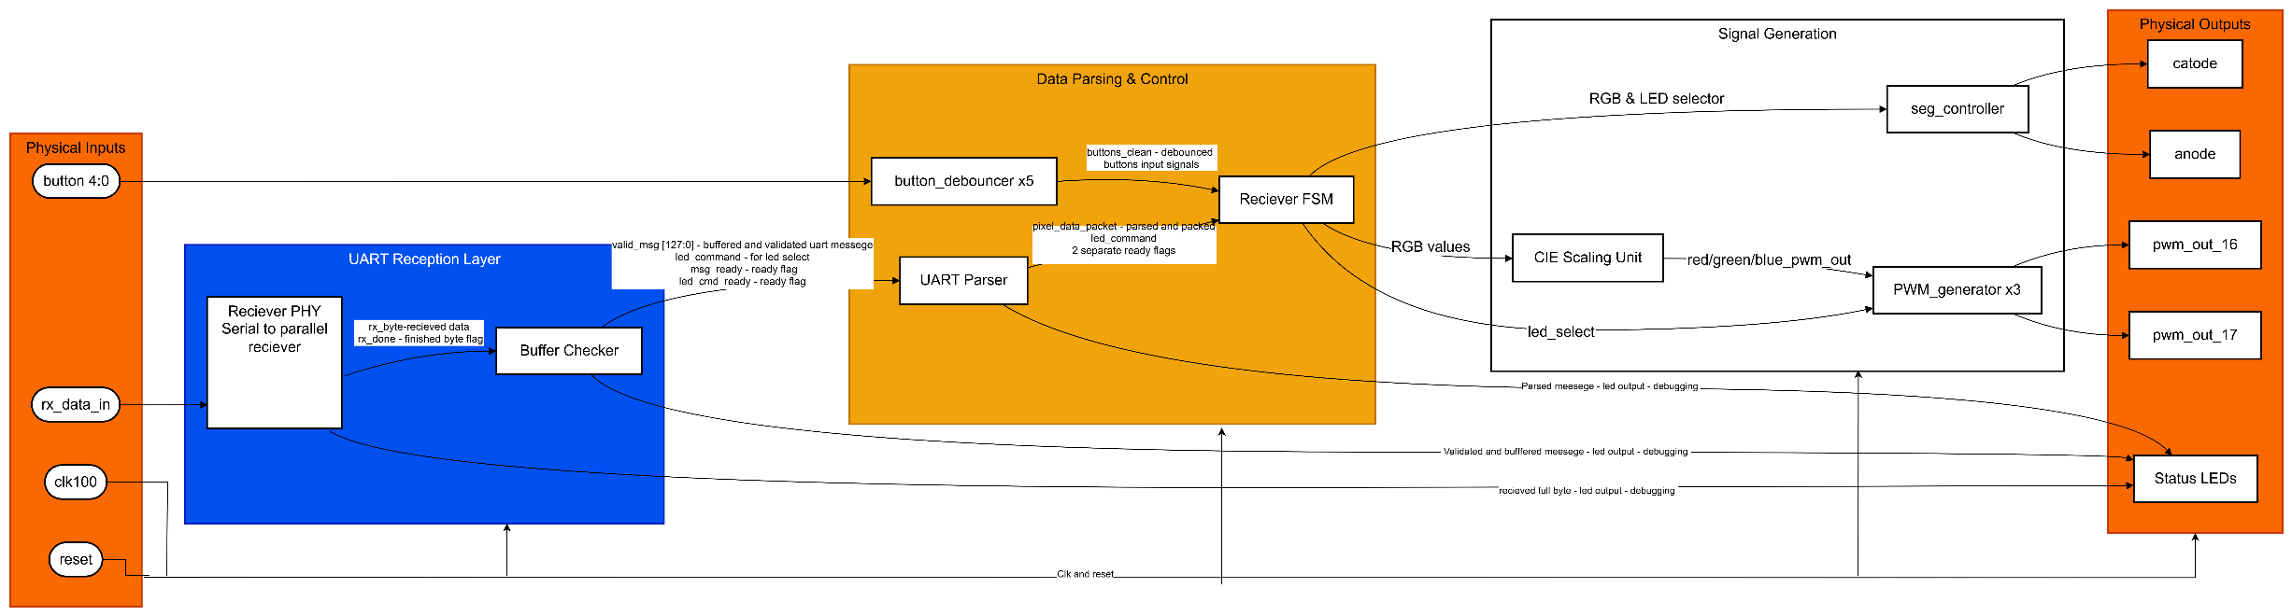
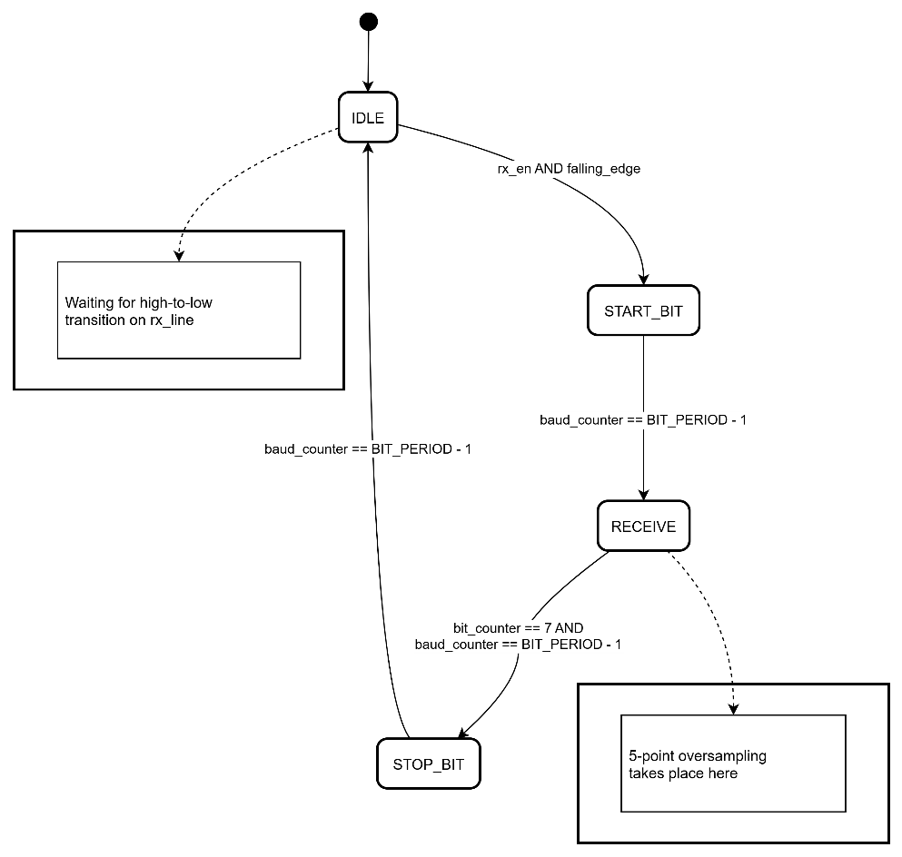
UATR Rx State Machine Diagram

Simulation waveform diagram
PWM Generator:
Duty Cycle input = 0x100 , 0x200 … ( 25% , 50 % , 75% , 100%)
also tested – duty cycle > 1024 100%
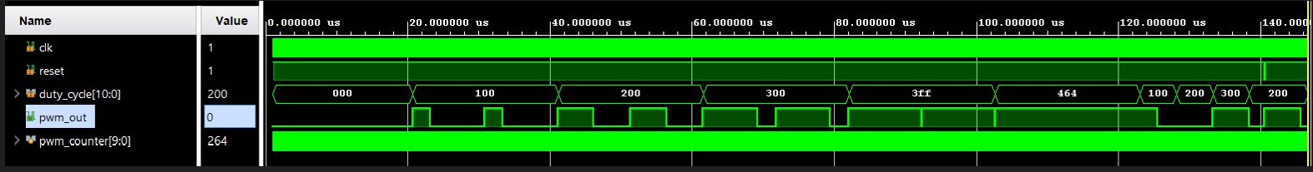
PWM signal output

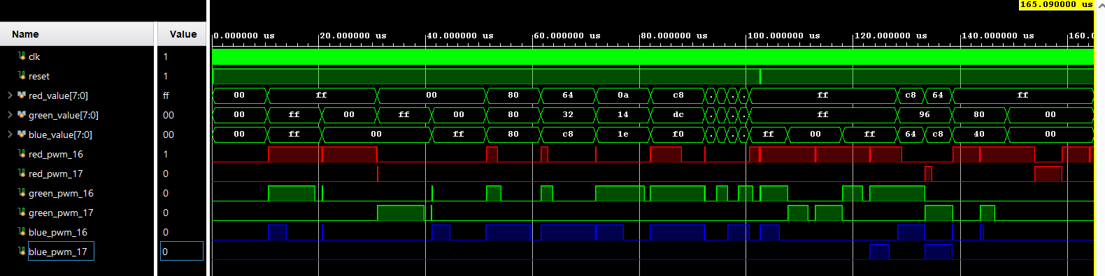
CIE scaler unit ->PWM Generator
This simulation tests the 3 PWM generation and the led select – no 2 same color leds works simultaneously .

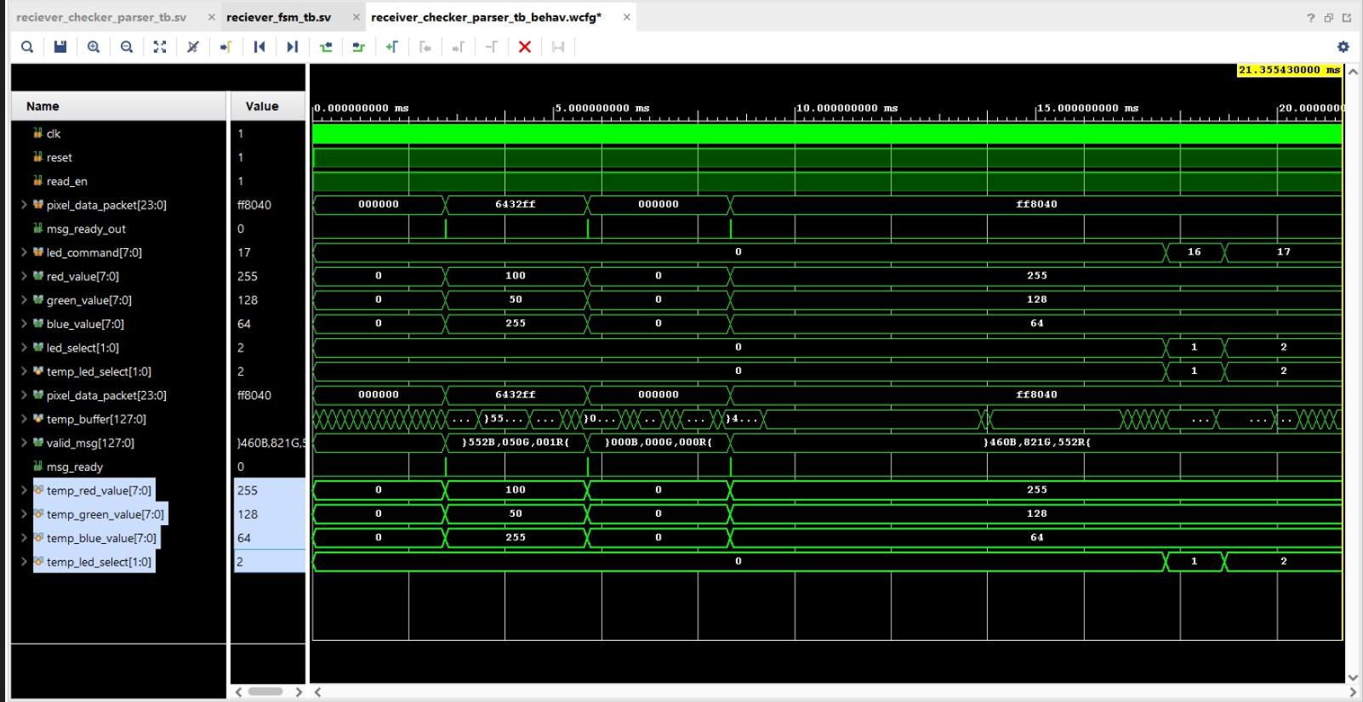
Full data-path: PHY->Buffer Checker->PARSER->Sys FSM:
Parsed Messages to hexadecimal
Buffered 16 Byte – UART received message

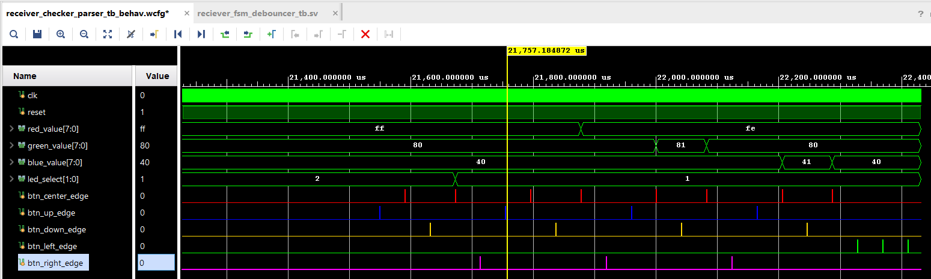
Full UART layer + data parsing and control FSM :
Test Case:
- btn_up -> btn center – already on led #2 nothing happens
- btn_down -> btn center – led select to led #1
- btn_right -> btn_up -> btn center – move control to red value and raise, nothing happens – red at max value
- btn_down -> btn center decrease red value by 1
- btn_right -> btn_up -> btn center - move control to blue led and raise value by 1
- btn_down -> btn center - decrease blue value by 1
- btn_right -> btn_up -> btn center - move control to green led and raise value by 1

Synthesis Report
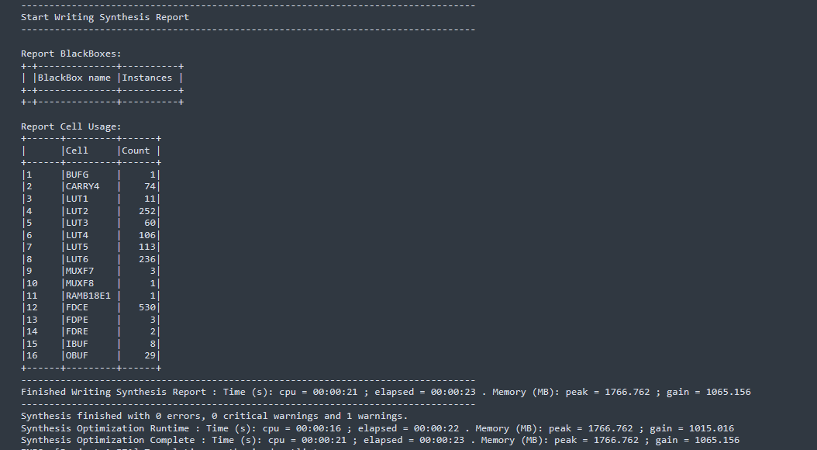

Successful Bitstream:

